CSE420
Samuel Marrujo
Professor Yu
Homework 1

Bresenham
In this part of the homework, it was a modification of the program to introduce the |m| > 1 part of the algorithm. After some modifications to the program, and adding in the functions asked for, the result was the following reproduction of the figure. Because of this change to the functions and the addition of the figure, I believe I was able to accomplish this task successfully, since there were no errors and the display window was changed. Here are my results for this program:

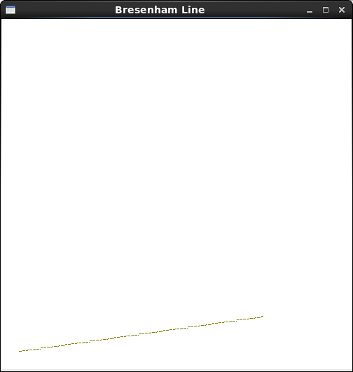

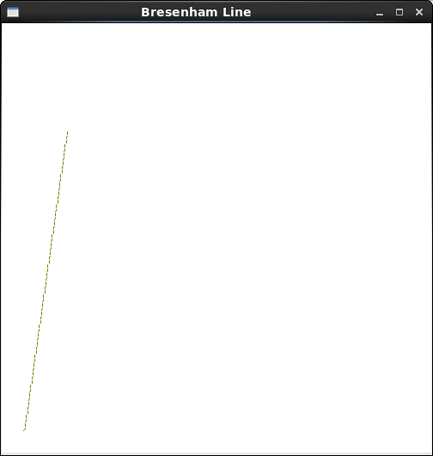
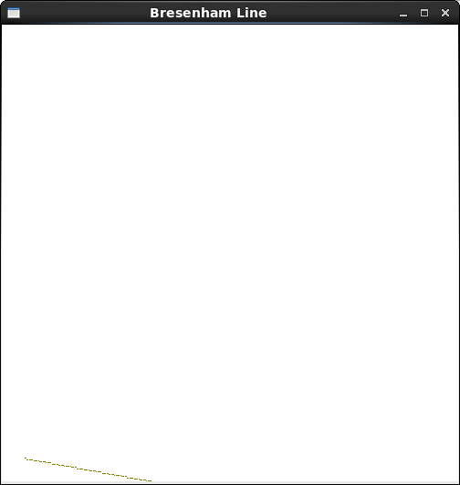
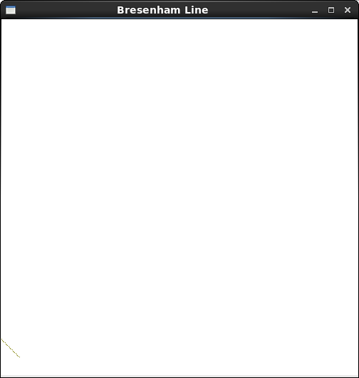
//bline.cpp : Bresenham Line algorithm, works for |m| <= 1, |m| > 1

#include <GL/glut.h>
#include <stdio.h>
#include <math.h>

void init(void)
{
glClearColor(1.0,1.0,1.0,0.0);
glMatrixMode(GL_PROJECTION);
gluOrtho2D(0.0,400.0,0.0,400.0);
}

void setPixel(GLint x,GLint y)
{
glBegin(GL_POINTS);
glVertex2i(x,y);
glEnd();
}

void line()
{
int x0 = 20, y0 = 20, xn = -300, yn = 60, x, y;
double dx, dy, //deltas
pk, //decision parameter
k; //looping variable
double m, n;

glClear(GL_COLOR_BUFFER_BIT);
glColor3f( 0.5 , 0.5, 0);
setPixel(x0, y0); //plot first point

// difference between starting and ending points
dx = xn - x0; //-320
dy = yn - y0; //40
pk = 2 * dy - dx;
x = x0; y = y0;
m = dy/dx; // 40/-320 = -1/8
n = abs(m);

if (n <= 1) {
if (dx > 0) {
for ( k = 0; k < dx-1; ++k ) {
if ( pk < 0 ) {
if (xn > 0 && yn > 0)
pk = pk + 2 * dy;
else //calculate next pk
pk = pk - 2 * dy; //next pixel: (x+1, y )
}
else {
//next pixel: (x+1, y+1)
pk = pk + 2*dy - 2*dx; //calculate next pk
if (yn > 0)
++y;
else
--y;
}
if (xn > 0)
++x;
else
--x;
setPixel( x, y );
}
}
else {
for ( k = 0; k < -dx-1; ++k ) {
if ( pk < 0 ) {
if (xn > 0 && yn > 0)
pk = pk + 2 * dy;
else //calculate next pk
pk = pk - 2 * dy; //next pixel: (x+1, y )
}
else {
if (xn > 0) //next pixel: (x+1, y+1)
pk = pk + 2*dy - 2*dx; //calculate next pk
else
pk = pk - 2*dy - 2*dx;
if (yn > 0)
++y;
else
--y;
}
if (xn > 0)
++x;
else
--x;
setPixel( x, y );
}
}
}
else if (n > 1) {
for ( k = 0; k < dy-1; ++k ) {
if ( pk < 0 ) {
if (xn > 0 && yn > 0)
pk = pk + 2 * dx;
else
pk = pk - 2 * dx;

}
else {

pk = pk + 2*dx - 2*dy;
if (xn > 0)
++x;
else
--x;
}
if (yn > 0)
++y;
else
--y;
setPixel( x, y);
}
}

glFlush();
}

int main(int argc,char **argv){
glutInit(&argc,argv);
glutInitDisplayMode(GLUT_SINGLE|GLUT_RGB);
glutInitWindowPosition(0,0);
glutInitWindowSize(500,500);
glutCreateWindow("Bresenham Line");
init();
glutDisplayFunc( line );
glutMainLoop();
return 0;
}
SDL/Surface

In this part of the lab, we were to create an animation of a line that rotates from the center of the screen. As the sequence is not screenshottable, I have the following code to represent it based from hook.cpp in the Lab:

/*
draw_demo.cpp
Demonstrate the use of turtle grapics using the surface class developed
by T.L. Yu
edited by Samuel Alex Marrujo

@Author: T.L. Yu, April 15, 2006
Revised on 2013/09/30
*/
#include <SDL/SDL.h>
#include <stdlib.h>
#include <stdio.h>

#include "draw.h"
#include "surface.h"

//draw a hook
void draw_hook ( Surface &surf, int L )
{
surf.forward ( L, 1 );
}

void draw_arc ( Surface &surf, int L ) {

for(int i = 0; i < 6; ++i) {
surf.forward(L,1);
surf.turn(15);
}
}

//draw a star pattern
void draw_star( Surface &surf, int L )
{
for ( int i = 0; i < 5; ++i ) {
surf.forward( L, 1 );
surf.turn( 144 );
}
}

//draw an n-sided regular polygon
void draw_polygon ( Surface &surf, int n, int radius, float rotAngle )
{
if ( n < 3 ) return; //bad number of sides
int cx = surf.getCP().x;
int cy = surf.getCP().y;
double angle = rotAngle * 3.14159265 / 180; //initial angle
double angleInc = 2 * 3.14159265 / n; //angle increment
surf.moveTo ( ( int) (radius * cos( angle ) + cx),
( int ) ( radius * sin ( angle ) + cy ) );
for ( int k = 0; k < n; k++ ) { //repeat n times
angle += angleInc;
surf.lineTo ( ( int) (radius * cos( angle ) + cx),
( int ) ( radius * sin ( angle ) + cy ) );
}
} //draw_polygon

//draw rosette with N-sided polygon
void rosette (Surface &surf, int N, int radius )
{
if ( N < 3 ) return;
Point pt[N+1];

int cx = surf.getCP().x;
int cy = surf.getCP().y;
double angle = 0; //initial angle
double angleInc = 2 * 3.14159265 / N; //angle increment
pt[0] = Point ( ( int) (radius * cos( angle ) + cx),
( int ) ( radius * sin ( angle ) + cy ) );
for ( int k = 1; k < N; k++ ) { //repeat n times
angle += angleInc;
pt[k] = Point ( ( int) (radius * cos( angle ) + cx),
( int ) ( radius * sin ( angle ) + cy ) );
}
for ( int i = 0; i < N - 1; i++ ) {
for ( int j = i + 1; j < N; j++ ) {
surf.moveTo ( pt[i] ); //connect all vertices
surf.lineTo ( pt[j] );
}
}
} //rosette

int main()
{

#ifndef ARM
const int VWIDTH = 640;
const int VHEIGHT = 480;
#else
const int VWIDTH = 320;
const int VHEIGHT = 240;
#endif

const Point center ( VWIDTH/2, VHEIGHT/2 ); //center of screen
Surface surf( VWIDTH, VHEIGHT, (char *) "Draw_demo" );

surf.clearScreen(); //clear screen
surf.updateSurface();
SDL_Delay ( 100 ); //dealy one second, just for demo

surf.setBackgroundColor ( 0xe0, 0xe0, 0xe0 ); //set background to grey

//draw a hook
//surf.setColor ( 0xff, 0, 0 ); //using red color
//surf.moveTo ( center ); //move to center of screen
//surf.turnTo ( 0 ); //points horizontally
//draw_hook ( surf, 180 );

//draw a star
//surf.setColor ( 0, 0xff, 0 ); //using green color
//surf.moveTo ( center.x + 90, center.y );
//surf.turnTo ( 0 ); //points horizontally
//draw_star ( surf, 50 );

//draw an octagon
surf.setColor ( 0x00, 0, 0 ); //using black color
/*surf.moveTo ( center.x, center.y - 90 );
// draw_polygon ( surf, 8, 40, 0 ); //draw an octagon
draw_polygon ( surf, 6, 40, 0 ); //draw a hexagon

surf.setColor ( 0xBF, 0, 0 );
surf.moveTo (center.x, center.y - 180 );
draw_polygon ( surf, 32, 40, 0 ); //draw a circle

surf.setColor ( 0xFF, 0, 0 );
surf.moveTo (center.x-60, center.y-10);
surf.turnTo(0);
draw_arc(surf, 30); //draw an arc
*/
for (int i=0;i<360;i=i+10) {
surf.moveTo( center.x, center.y );
surf.turnTo(i);
draw_hook(surf, 50);
surf.updateSurface();
SDL_Delay ( 500 );
surf.clearScreen();
}
//draw an 8-sided rosette
//surf.setColor ( 0, 0, 0 ); //using black color
//surf.moveTo ( center.x - 90, center.y + 90 );
//rosette ( surf, 8, 50 );

surf.updateSurface();
SDL_Delay ( 5000 ); //display 5 seconds before exit
return 1;
}
Plots
This required a change in the original function to e^-|x|sin(2*pi(x)). Using the following code, the entire function is shown and scaled properly as seen here:
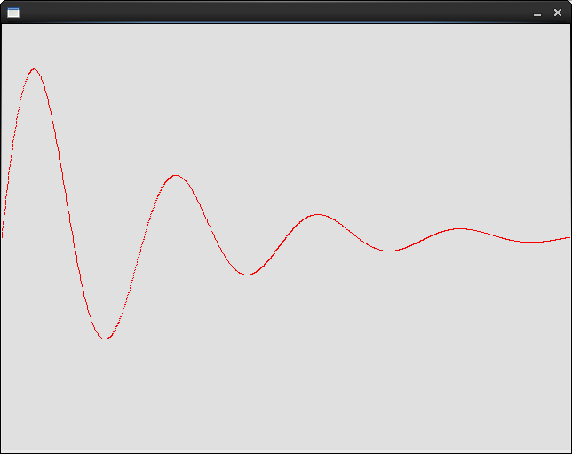
/*
plots.cpp
Demonstrate the drawing of a line using the surface class developed
by T.L. Yu

@Author: T.L. Yu, April 15, 2006

*/
#include <SDL/SDL.h>
#include <stdlib.h>
#include <stdio.h>

#include "draw.h"
#include "surface.h"

using namespace std;

double f ( double x )
{
double y = exp ( -fabs ( x ) ) * sin ( (2) * 3.1415926 * x );

return y;
}

int main()
{

const int VWIDTH = 640;
const int VHEIGHT = 480;

const Point center ( VWIDTH/2, VHEIGHT/2 ); //center of screen
Surface surf( VWIDTH, VHEIGHT, (char *) "draw_line" );

surf.clearScreen(); //clear screen
surf.updateSurface();
SDL_Delay ( 1000 ); //dealy one second, just for demo

surf.setBackgroundColor ( 0xe0, 0xe0, 0xe0 ); //set background to grey

//draw a line
surf.setColor ( 0xff, 0, 0 ); //using red color

int sx, sy;
double x, y, a, b, c, d;
a = VWIDTH / 4;
c = 0;
b = -VHEIGHT / 2.0;
d = VHEIGHT / 2.0;

x = 0.0; //initial position
y = f ( 0.0 );
sx = (int) ( a * x + c );
sy = (int) ( b * y + d );
surf.moveTo ( sx, sy );

for ( x = 0; x < 4; x += 0.005 ) {
y = f ( x );
sx = (int) ( a * x + c );
sy = (int) ( b * y + d );
surf.lineTo ( sx, sy );
}

surf.updateSurface();
SDL_Delay ( 10000 ); //display 10 seconds before exit
return 1;
}
Figures
I did the following figures for the homework assignment. Here are the five figures asked for:

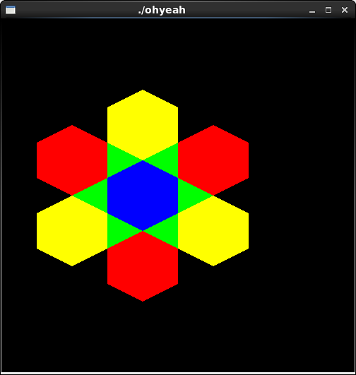
/*
* ohyeah.cpp
* This program draws geometric primitives and
* their attributes.
*/
#include <GL/glut.h>
#include <stdlib.h>

#define drawOneLine(x1,y1,x2,y2) glBegin(GL_LINES); \
glVertex2f ((x1),(y1)); glVertex2f ((x2),(y2)); glEnd();

void init(void)
{
glClearColor (0.0, 0.0, 0.0, 0.0);
glShadeModel (GL_FLAT);
}

void display(void)
{

glClear (GL_COLOR_BUFFER_BIT);

glColor3f(0,0,1);
glPolygonMode( GL_FRONT, GL_FILL );
glBegin (GL_POLYGON);
glVertex2i(200,200);
glVertex2i(250,225);
glVertex2i(250,275);
glVertex2i(200,300);
glVertex2i(150,275);
glVertex2i(150,225);
glVertex2i(200,200);
glEnd();
glColor3f(1, 1, 0);
glPolygonMode(GL_FRONT, GL_FILL);
glBegin (GL_POLYGON);
glVertex2i(200,300);
glVertex2i(250,325);
glVertex2i(250,375);
glVertex2i(200,400);
glVertex2i(150,375);
glVertex2i(150,325);
glVertex2i(200,300);
glEnd();
glColor3f(1, 0, 0);
glBegin (GL_POLYGON);
glVertex2i(200,100);
glVertex2i(250,125);
glVertex2i(250,175);
glVertex2i(200,200);
glVertex2i(150,175);
glVertex2i(150,125);
glVertex2i(200,100);
glEnd();
glColor3f(1, 1, 0);
glBegin (GL_POLYGON);
glVertex2i(250,175);
glVertex2i(250,225);
glVertex2i(300,250);
glVertex2i(350,225);
glVertex2i(350,175);
glVertex2i(300,150);
glVertex2i(250,175);
glEnd();
glColor3f(1, 1, 0);
glBegin (GL_POLYGON);
glVertex2i(150,175);
glVertex2i(150,225);
glVertex2i(100,250);
glVertex2i(50,225);
glVertex2i(50,175);
glVertex2i(100,150);
glVertex2i(150,175);
glEnd();
glColor3f(1, 0, 0);
glBegin (GL_POLYGON);
glVertex2i(100,250);
glVertex2i(150,275);
glVertex2i(150,325);
glVertex2i(100,350);
glVertex2i(50,325);
glVertex2i(50,275);
glVertex2i(100,250);
glEnd();
glColor3f(1, 0, 0);
glBegin (GL_POLYGON);
glVertex2i(300,250);
glVertex2i(350,275);
glVertex2i(350,325);
glVertex2i(300,350);
glVertex2i(250,325);
glVertex2i(250,275);
glVertex2i(300,250);
glEnd();
glColor3f(0, 1, 0);
glBegin (GL_POLYGON);
glVertex2i(250,325);
glVertex2i(250,275);
glVertex2i(200,300);
glVertex2i(250,325);
glEnd();
glBegin (GL_POLYGON);
glVertex2i(200,300);
glVertex2i(150,275);
glVertex2i(150,325);
glVertex2i(200,300);
glEnd();
glBegin (GL_POLYGON);
glVertex2i(150,275);
glVertex2i(100,250);
glVertex2i(150,225);
glVertex2i(150,275);
glEnd();
glBegin (GL_POLYGON);
glVertex2i(150,225);
glVertex2i(200,200);
glVertex2i(150,175);
glVertex2i(150,225);
glEnd();
glBegin (GL_POLYGON);
glVertex2i(200,200);
glVertex2i(250,225);
glVertex2i(250,175);
glVertex2i(200,200);
glEnd();
glBegin (GL_POLYGON);
glVertex2i(250,225);
glVertex2i(300,250);
glVertex2i(250,275);
glVertex2i(250,225);
glEnd();
glFlush();
}

void reshape (int w, int h)
{
glViewport (0, 0, (GLsizei) w, (GLsizei) h);
glMatrixMode (GL_PROJECTION);
glLoadIdentity ();
gluOrtho2D (0.0, (GLdouble) w, 0.0, (GLdouble) h);
}

void keyboard(unsigned char key, int x, int y)
{
switch (key) {
case 27:
exit(0);
break;
}
}

int main(int argc, char** argv)
{
glutInit(&argc, argv);
glutInitDisplayMode (GLUT_SINGLE | GLUT_RGB);
glutInitWindowSize (500, 500);
glutInitWindowPosition (100, 100);
glutCreateWindow (argv[0]);
init ();
glutDisplayFunc(display);
glutReshapeFunc(reshape);
glutKeyboardFunc(keyboard);
glutMainLoop();
return 0;
}

